Megan N. Bozios, Principal
John C. Anzul, Ed.D. Superintendent

May is Mental Health Awareness Month!

At OPS, we are celebrating Mental Health Awareness Month by providing families with information and exercises designed to foster conversations about mental health between parents/guardians and children. The information and exercises will be focused on identifying stressors, identifying stress symptoms, ways to manage stress, and developing coping skills.

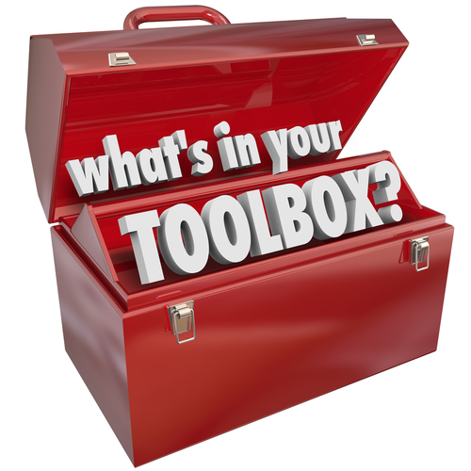

This is the 4th packet with instructions
to build your own
FAMILY COPING SKILLS TOOLBOX:
All your favorite feel-good tools
in one place!
(Psst! This is another FUN packet!)

Review
In the first packet, we took a look at what stress is, what causes stress, and how to know when you are stressed. The 2nd packet looked at your current diet, sleep, exercise and leisure habits to see if any improvements could be made to help prevent stress. The 3rd packet addressed “coping skills” that can help manage stress in the moment, and bring it back down to tolerable levels. This week’s packet will provide instructions on how to make your own Family Coping Skills Toolbox to have on hand for whenever you feel the need to bring stress levels down a few notches.

Why a Family Coping Skills Toolbox?
As you may recall, coping skills are the methods people use to deal with stressful situations. There are adaptive and maladaptive coping strategies. The purpose of a coping skills toolbox is to help you choose adaptive strategies by making them accessible and easier to employ when you need them. The idea is to gather all your favorite coping tools in one place, such as on a shelf in the family room (make sure it’s within reach of the children!). Then when you or a family member is feeling stressed, you can remind each other to use it! You can even use it together!

Hopefully, you’ve taken the time to try some new strategies from last week’s checklists and practice them to see what really works. Once you know what strategies you like, follow the instructions below to guide you in assembling your toolbox. There are many suggestions and resources listed. Don’t feel like you need to include all of them. Choose what works for you and your family to make your toolbox your own.

------------------------------------------------FAMILY FORUM TIME!------------------------------------------------------
Family Coping Skills Toolbox
The following graphic will guide you through the process of selecting items to include in your toolbox. The “box” itself can be an actual box or basket, crate, bag, etc. (You may wish to print this page for easy reference while assembling your toolbox.) Links to additional examples/resources for each element are listed below. These are just suggestions; your toolbox can include anything that works for you and your family.

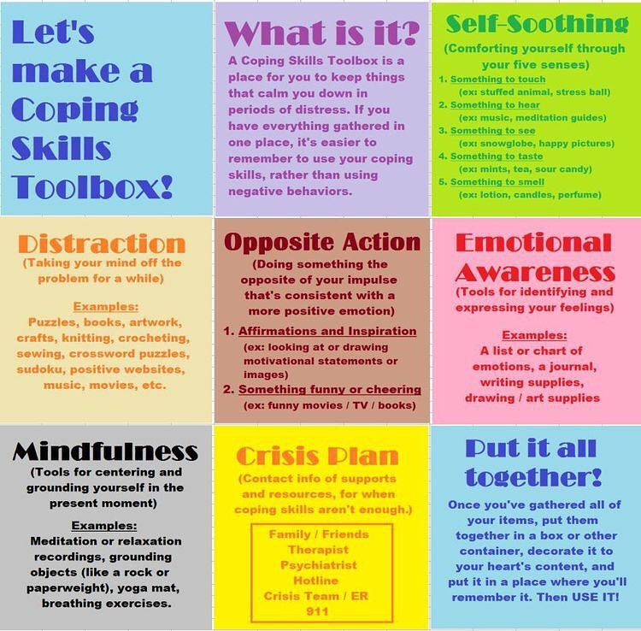

Additional examples/resources for the above:
Self-soothing resources:
Touch: Make your own stress-ball
Hear: 5-minute and under guided meditations for beginners
See: 6 Ways to Make a Calm Down Jar

Opposite Action: 10 Practical Examples of Opposite Action (Read to learn more)
Changing Emotions by Acting Opposite to the Current Emotion (print for ready-reference in your toolbox)

Emotional Awareness: Free printable emotions poster
Free printable emotions chart
Free printable emotions flashcards

Mindfulness: Deep breathing printables (free)

Some pictures of others’ toolboxes:

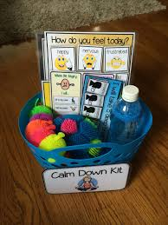

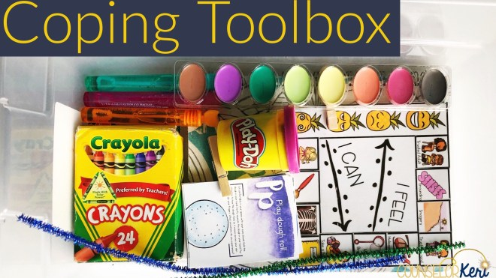
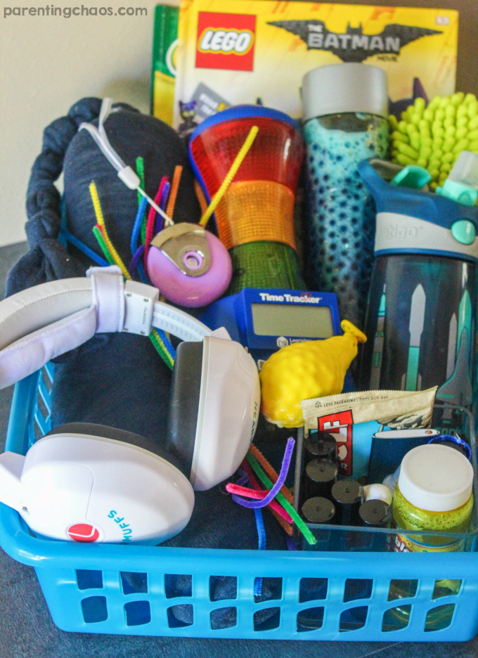

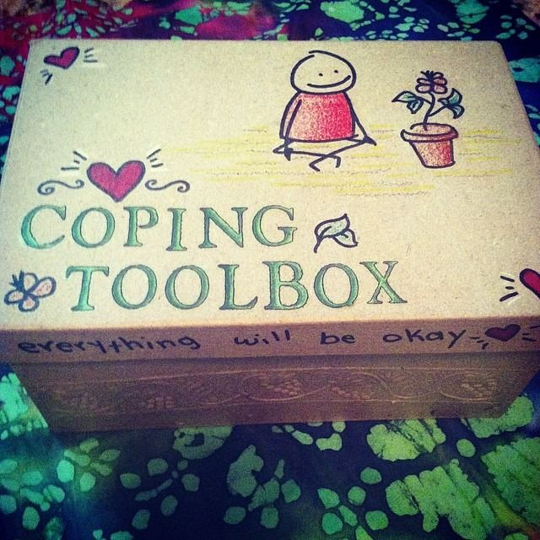

---------------------------------------------------------------------------------------------------------------------------------
A Word About Deep Breathing…Again (because it’s worth repeating!)
One technique that should be included in everyone’s toolbox is a deep breathing exercise. Also called belly breaths, diaphragmatic breathing, or abdominal breathing, this method has been scientifically proven to have profound effects on the heart, brain, digestion, immune system, and perhaps even the expression of genes.

There are many methods of deep breathing exercises including meditation, yoga, guided imagery, repetitive prayer, tai chi, and progressive muscle relaxation. And there are countless ways to help children learn how to belly breath correctly. For more information, please see the links listed under “To Learn More” below. Much like exercise has become an established practice for optimal health, so, too, will deep breathing practices become an essential part of wellness.

Next Steps
Once you’ve assembled your Family Coping Skills Toolbox, remember to use it! Remind each other to use it! Use it together! In fact, you don’t have to be stressed to use the toolbox because practicing the skills while you’re calm will help you remember to use/do them when you ARE stressed, and it will actually make the skills more effective when you need them.

IMPORTANT: If you feel you or someone you love could benefit from the help of a professional therapist (counselor, social worker, psychiatrist), please see the downloadable list of Counseling Resources in the OPS Area included at the end of the blog post.

To Learn More
If you’d like to learn more about coping skills toolboxes and/or you’re interested in even more resources/strategies to include, please visit the following online resources:
Fostering a Growth Mindset
Circle of Concern/Influence/Control
www.CopingSkillsForKids.com
Deep Breathing Exercises for Kids
Wheel of Coping Skills (an alternative to a toolbox)
My Cope-Cake

